**Amazon S3 [Global]**

**Buckets are regional**

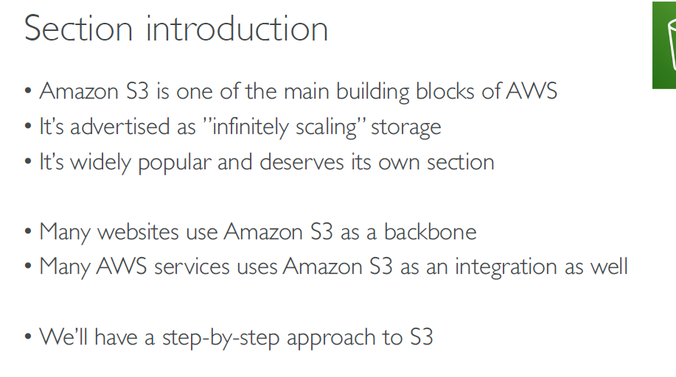

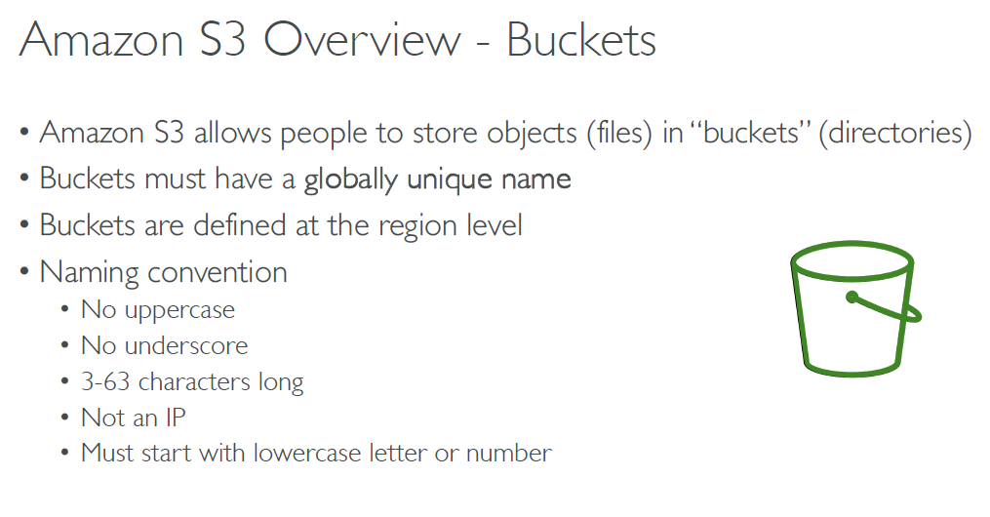

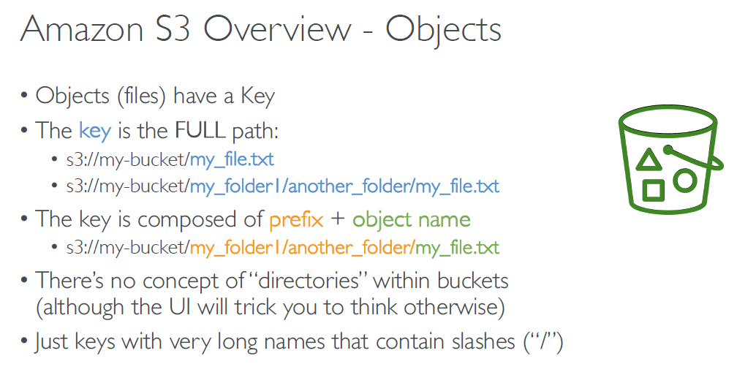

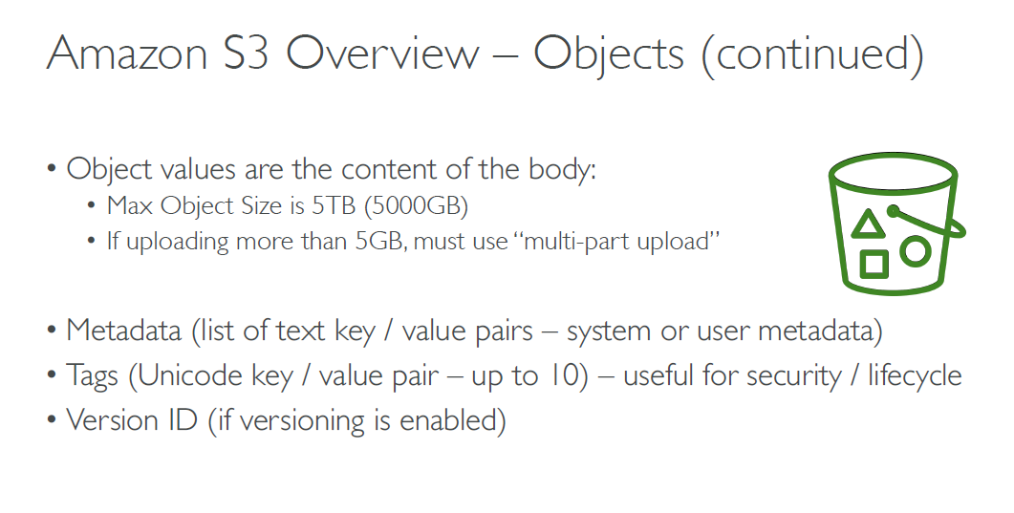

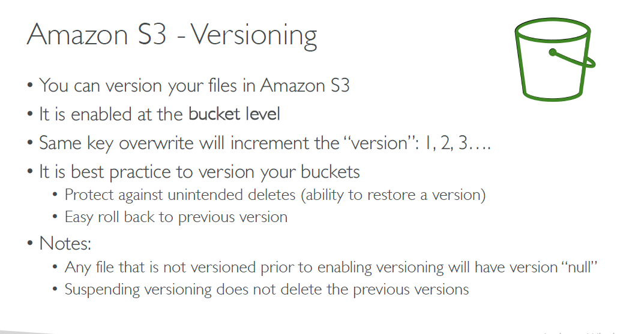

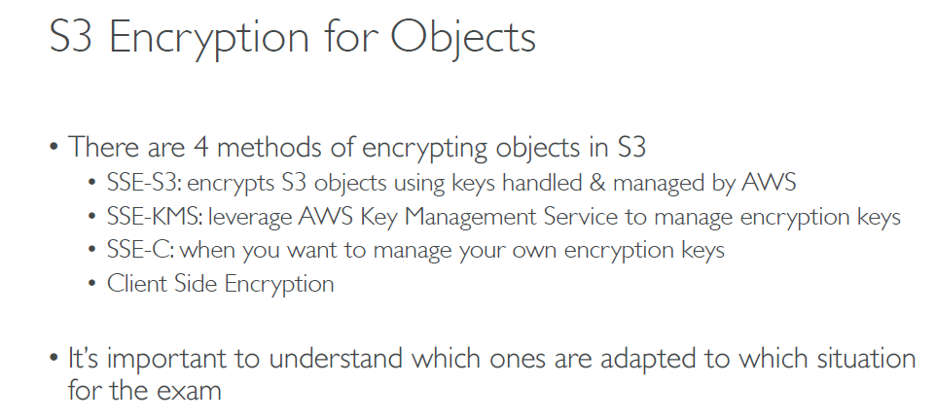

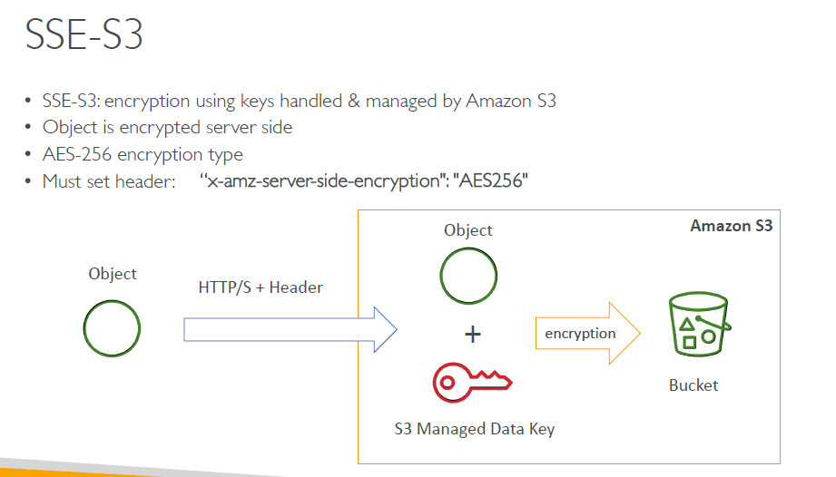

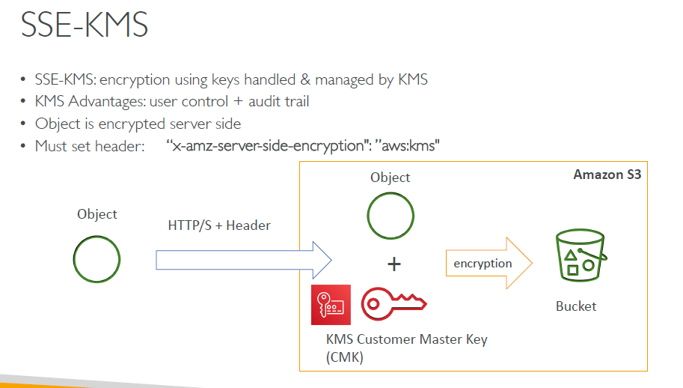

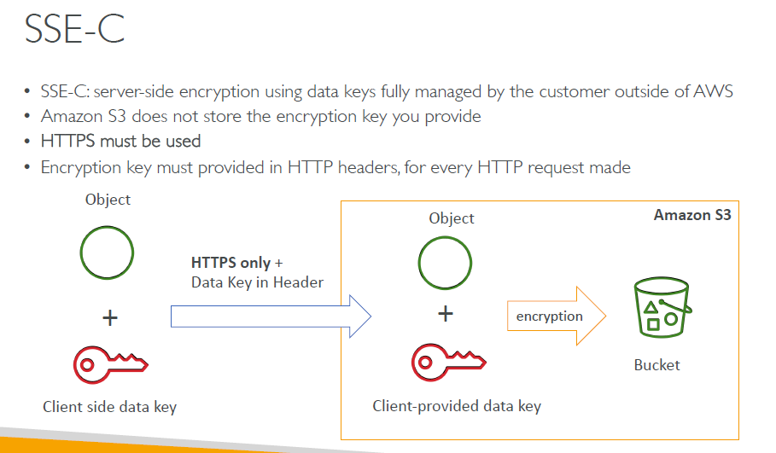

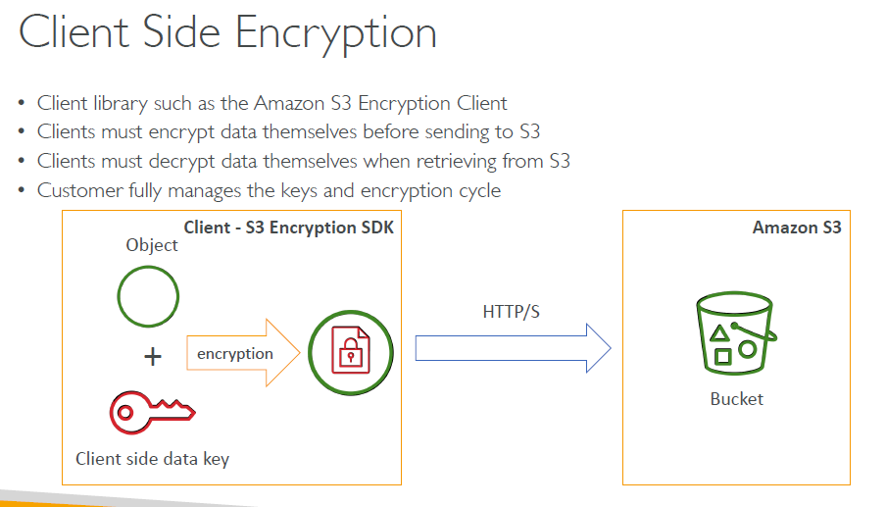

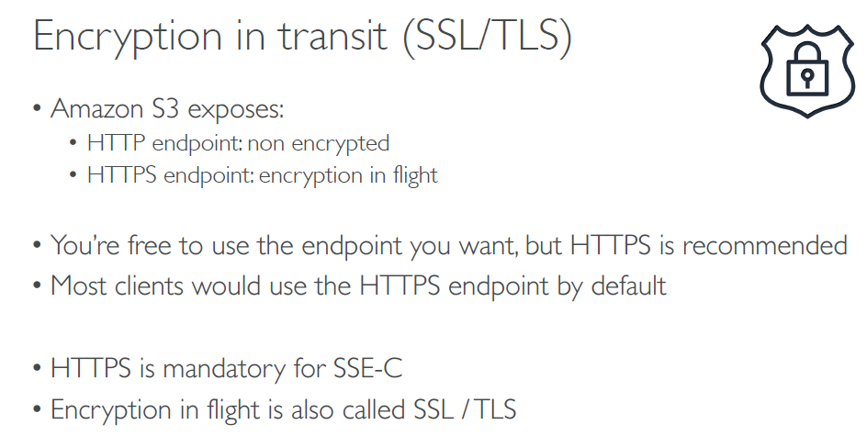

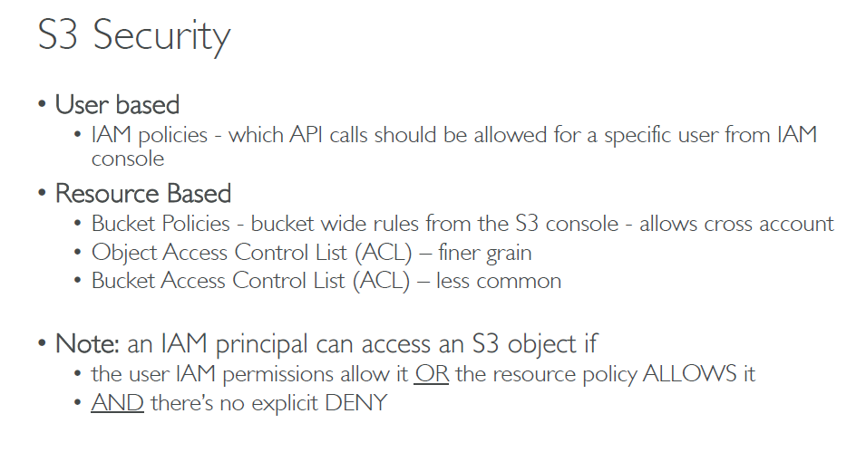

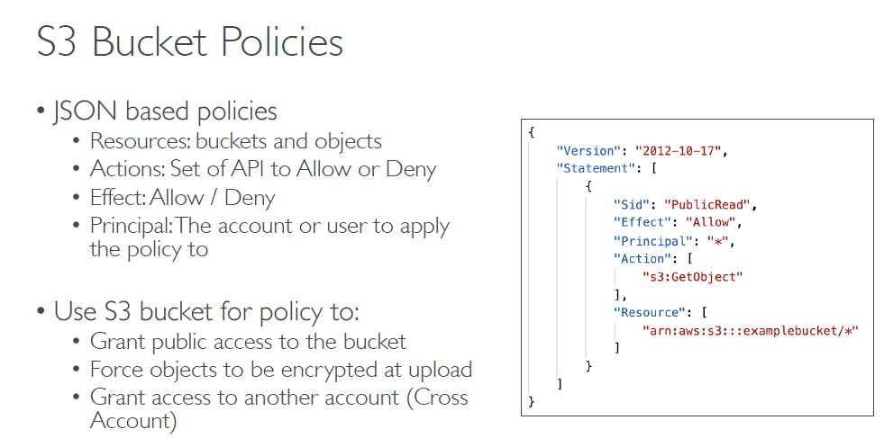

Bucket Policy Hands On

Select the Bucket…..Permissions….Bucket Policy…Policy generator

* Select the type of policy: S3 bucket policy
* Effect Allow / Deny
* Principal: * everyone
* AWS service: S3
* Actions: Put objects
* ARN: /*

ADD conditions

Key: select Encryption header [s3x-amz server side-encryption]

Value: true

If Encryption header is null then deny it.

Add statement

Condition 2nd Example:

Condition: stringnotequal

Key: select the header

Value: AE256

Deny any request if selected header is not equal to AE256

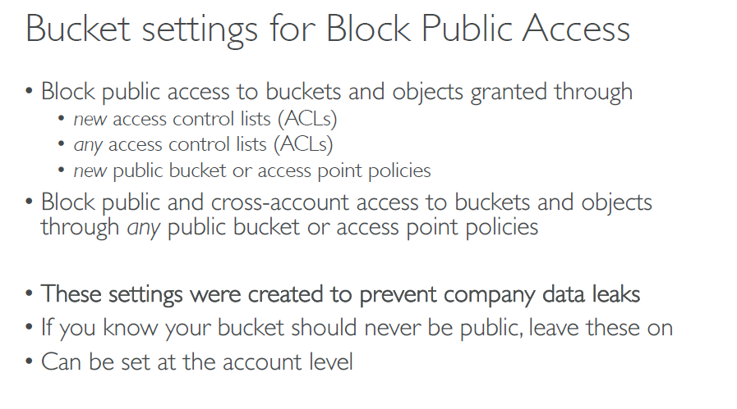

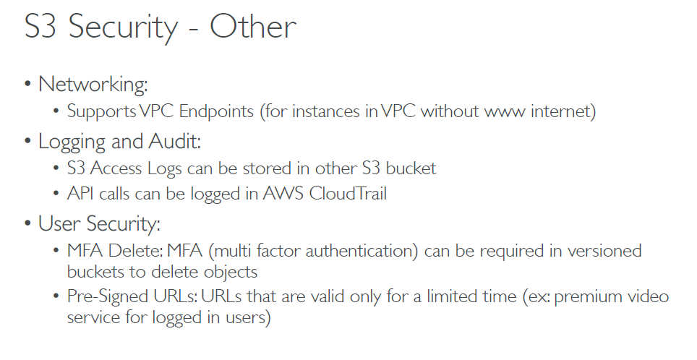

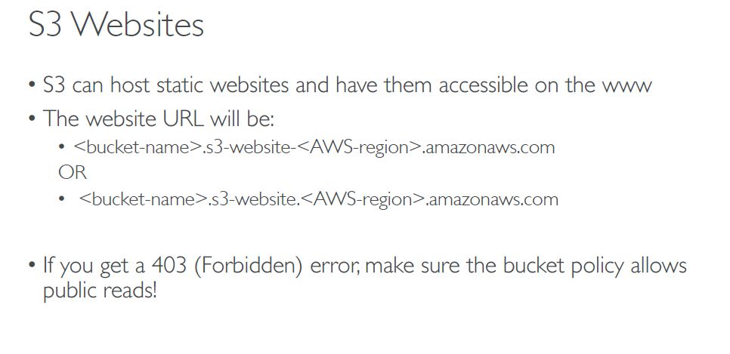

**Static hosting Hands On**

* Create bucket
* Upload Static content files to the bucket
* Properties……static webhosting ….index.html <static file name>
* You get the end points [url] in staPotic web hosting
* You might get 403 forbidden access denied.
* Because buckets are private & url is public..u need to give public access to the bucket.
* Permissions…Remove block public access.
* Then you need to create bucket policy as well
  + Policy Generator
  + Type: s3 bucket policy
  + Effect: allow
  + Principal: * [everyone]
  + Service: S3
  + Actions: GetObjects [view access]
  + ARN: arn number/*
  + Add statement & generate policy
  + Copy the policy and paste it.

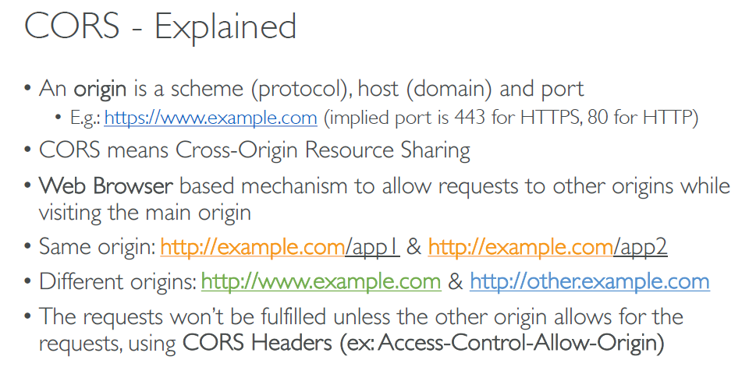

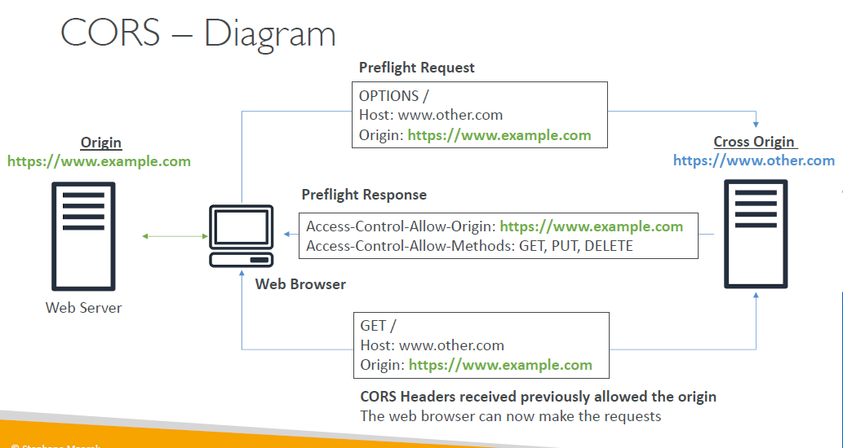

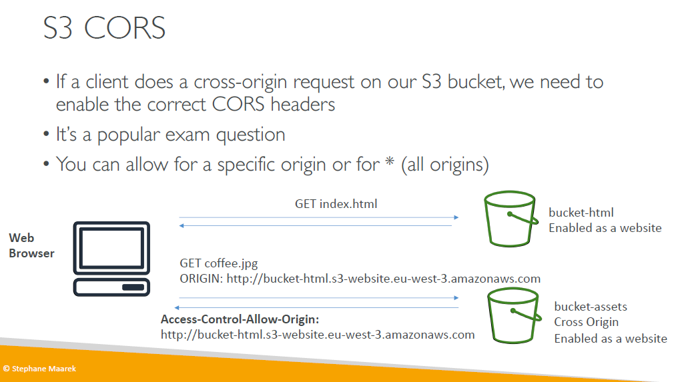

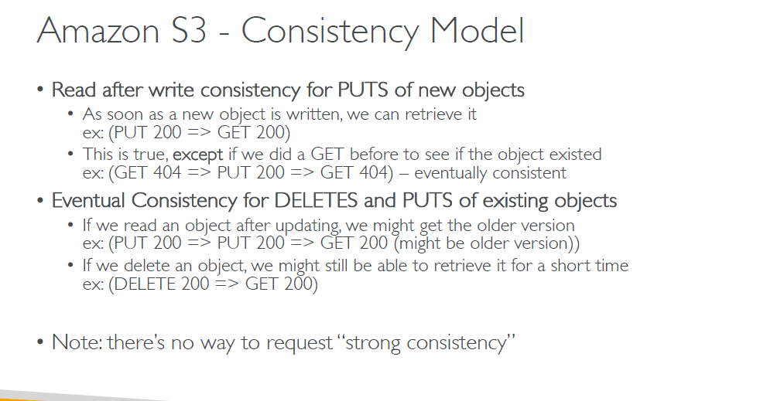

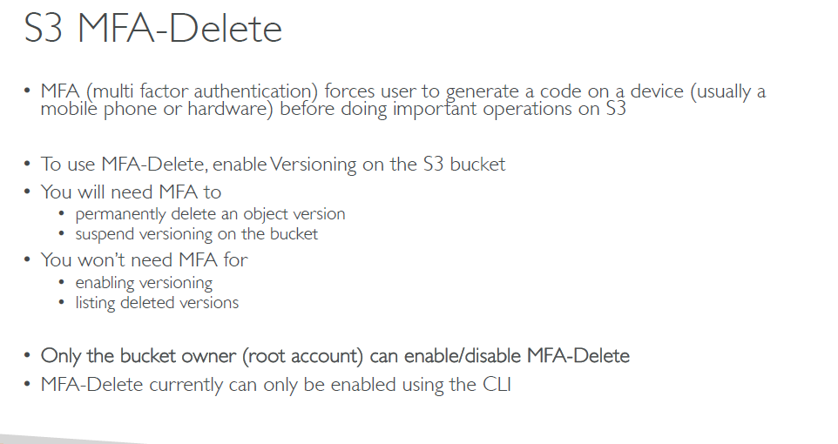

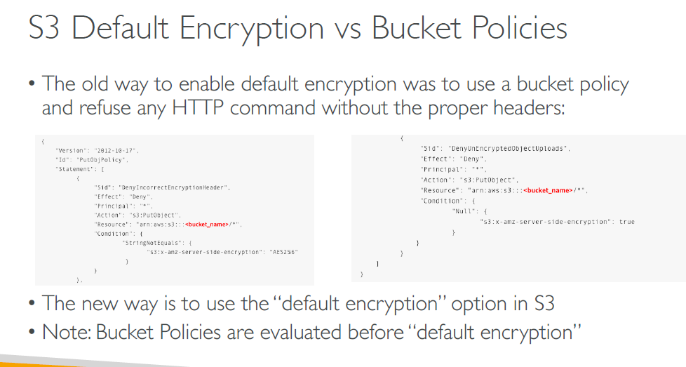

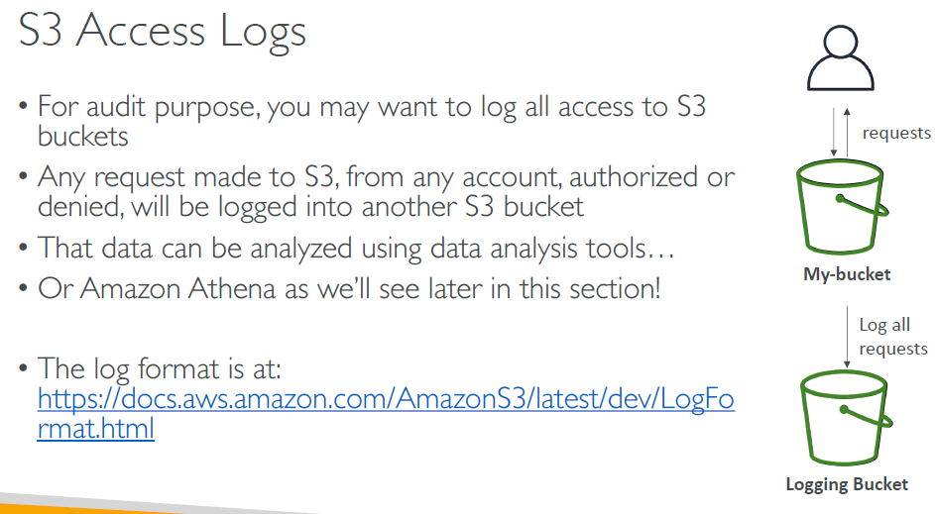

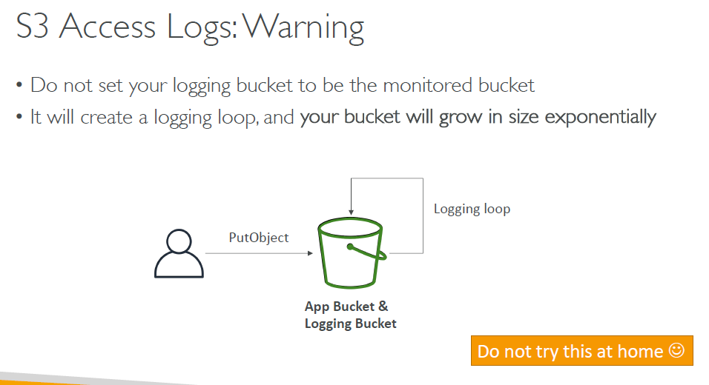

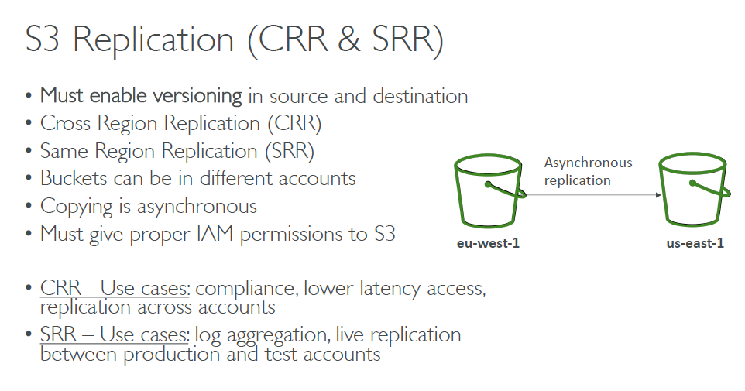

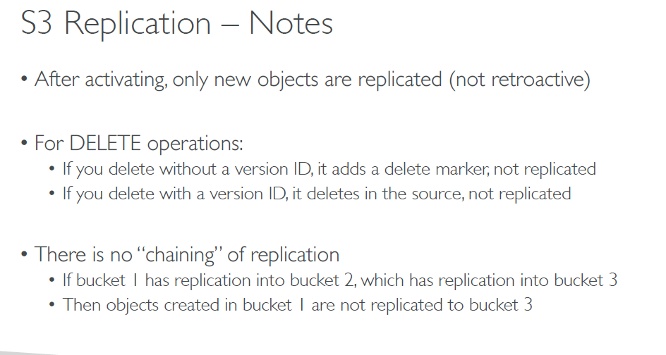

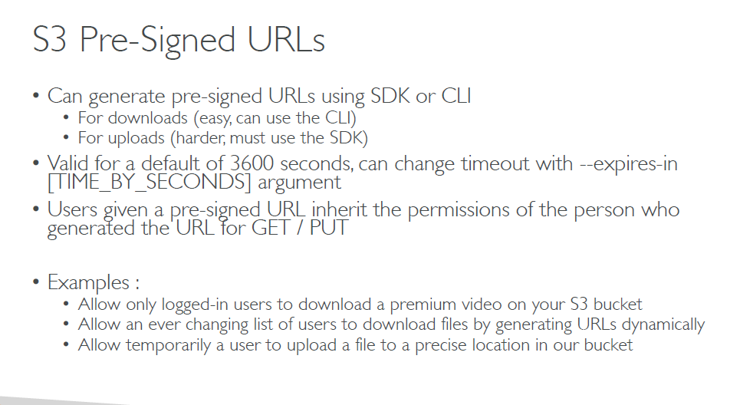

Pre signed URL CLI commands

* #aws configure set default.s3.signature_version s3v4
* **To create a pre-signed URL with the default one hour lifetime that links to an object in an S3 bucket**
* The following presign command generates a pre-signed URL for a specified bucket and key that is valid for one hour:
* aws s3 presign s3://awsexamplebucket/test2.txt
* **create a pre-signed URL with a custom lifetime that links to an object in an S3 bucket**
* The following presign command generates a pre-signed URL for a specified bucket and key that is valid for one week:
* aws s3 presign s3://awsexamplebucket/test2.txt --expires-in 604800 --region ap-south

